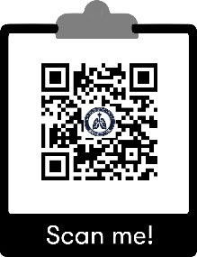
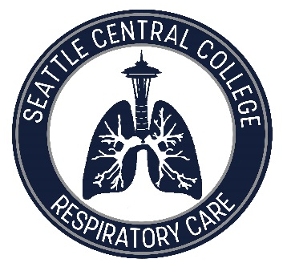
Seattle Central College's Respiratory Care track is a full-time, face-to-face, rigorous bachelor’s degree program that combines classroom training with practical, hands-on experience. This program will prepare you to become a member of a dedicated healthcare team that treats patients with cardiopulmonary disorders.
BAS in Allied Health Respiratory Care Track

How long is the program?
After you have completed the pre-requisites (about two years of work), the Respiratory Care track is 7 full-time quarters (just under 2 years) after which you graduate with a Bachelor of Applied Science and are ready to apply for a license as a Respiratory Therapist. Click here for more information about the curriculum: Program Quarter-by-Quarter Walk through Presentation

How can I learn more?
The Seattle Central Respiratory Care Program is at the beautiful Health Education Center on Beacon Hill with sweeping views overlooking the Puget Sound! Join us on campus for a tour and/or watch our virtual Respiratory Care BAS Program Information Session. You may also email us at RespiratoryCareBAS@seattlecolleges.edu

How do I apply?
Please get in touch and we are happy to help you plan out your prerequisites. The online application opens at the beginning of each year, with the program beginning in the fall. You can find the application here: https://apply.seattlecolleges.edu/respiratorycare
The minimum required documentation for applying:
- Unofficial transcripts showing successful completion of pre-requisites with a 2.0 or higher
- A full report for your TEAS scores, including composite score and all four sub scores
- A plan for completing your pre-requisites before the first quarter †

The program starts each Fall for 7 full-time, consecutive quarters to graduate with a BAS in the Spring. Use the pre-requisite worksheet to help you plan your pathway to becoming an RT!
Pre-requisite Worksheet |  |  | Done | Planned
BIOL& 160 | General Biology with Lab | 5
BIOL& 241 | Human Anatomy and Physiology I | 5
BIOL& 242 | Human Anatomy and Physiology II | 5
BIOL& 260 | Microbiology | 5
MATH& 146  or MATH 136 | Introduction to Statistics | 5
CHEM& 121 | Introduction to Chemistry | 5
CHEM& 122 or CHEM 131 | Introduction to Organic Chemistry OR Introduction to Organic Chemistry & Biochemistry | 5
ENGL& 101 | English Composition I | 5
ENGL& 102 | English Composition II | 5
PSYC& 100  or PSYC& 200 | Psychology | 5
HUM 105  or CMST 205 | Intercultural Communication OR Multicultural Communication | 5
Humanities elective | Courses in languages, communication, arts or film (example) | 5
AHE 168 | Medical Terminology (offered fully online) | 5
 |  | 65
NAME: SID:
†Applicants may have remaining pre-requisites to take at the time of application, but all entrance requirements must be completed before the first quarter in the program.

